Integrating Climate Change into Management Plans
Adaptation Workbook Process
Described in Forest Adaptation Resources: Climate change tools and approaches for land managers, 2nd edition (www.fs.usda.gov/research/treesearch/52760) and also available as an online tool at www.adaptationworkbook.org.

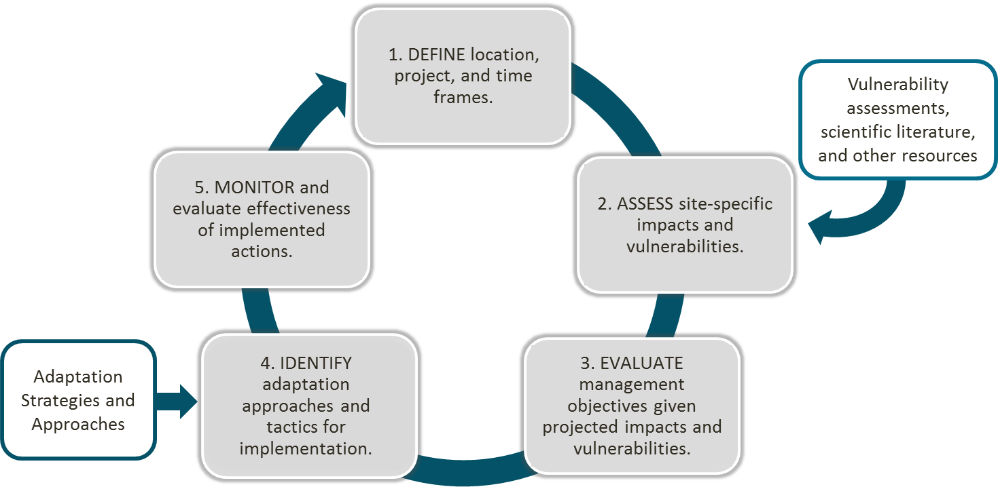

Vulnerability Assessments and Climate Assessments
Find regional forested ecosystem vulnerability assessments, and impacts described within the National Climate Assessment (2018) using the interactive climate impacts explorer tool:
www.adaptationworkbook.org/explore-impacts

Step 1: DEFINE location, project, and time frames.
What are your management goals and objectives for the project area? Pull these from your Step 1 worksheet.
Project Area
& Location:
Management Goals |  | Management Objectives

Step 2: ASSESS site-specific climate change impacts and vulnerabilities.
What climate change impacts and vulnerabilities are most important to this particular site?
- Select the climate change impacts that are most likely to affect your project.
Which of these regional climate change impacts is likely to affect your area? | How could these regional climate change impacts affect your local area? Which present the greatest risk, and why?
- Warmer temperatures (annual and seasonal)
- More days with extreme heat
- Fewer days with extreme cold
- Uncertain annual precipitation
- Altered seasonal changes in precipitation
- More frequent heavy precipitation events
- Less snow/shorter winter season
- Altered stream flows
- Reduced soil moisture in summer
- Longer growing season
- Potential for early spring thaws/late frosts
- Declines in alpine turf and dwarf shrublands
- Declines in streams, riparian areas, and wetland ecosystems
- Lack of seedling regeneration post-disturbance
- More frequent and intense storms
- Potential changes in wildfire
- Increases in insect pests and forest pathogens
- Increases in nonnative plant species
- Changes in patterns of herbivory
- Other:
- How vulnerable is your project area to climate change?
Vulnerability Ratings (pick one per time period) | Nearer term  (10-30 years) | Long term  (50+ years)
Low – Ecosystems are expected to readily cope with potential climate change impacts. Climate change is more beneficial to ecosystems than disruptive.
Moderate – Climate change impacts are expected to alter ecosystems, but ecosystems will be able to cope with some impacts.
High – Climate change impacts are expected to exceed the ability of the ecosystem to cope with impacts. Ecosystems may undergo changes that will disrupt important ecosystem functions and key environmental benefits.
Step 3: EVALUATE management objectives given projected impacts and vulnerabilities.
What management challenges and opportunities may occur as a result of climate change?
Based on the risks from climate change over the next 20-50 years, do you have confidence that your current management objectives will be successful using current (business-as-usual) management actions? Identify whether your objectives have high, medium, or low feasibility.
- High: We can do it! Opportunities > Challenges
- Low: We’ll need more resources or effort. Challenges > Opportunities

Greatest Management Challenges  from Climate Change | Greatest Management Opportunities  from Climate Change

The Northern Institute of Applied Science has led the development of Adaptation Strategies and Approaches for various natural resource topics, which can be used with the Adaptation Workbook. These “menus” provide topical lists of adaptation actions that not only help you move from broad ideas to specific actions and express the adaptation intent of your actions. Although menu items can be applied in various combinations to achieve desired outcomes, not all items on the menu will work together or work in every ecosystem. Land managers can use these menus to select appropriate actions based on their unique project location and goals.

- Forest Ecosystems
- Urban Forests
- Forested Watersheds
- Agriculture
- Tribal Perspectives
- Forest Carbon
- Recreation
- Non-Forested Wetlands
- Fire-Adapted Ecosystems
- Wildlife Management
- California Forests
- Great Lakes Coastal Ecosystems
- Inland Glacial Lake Fisheries
- Grassland Ecosystems (in prep)

Step 4: IDENTIFY adaptation approaches and tactics for implementation.
What actions can enhance the ability of the area to adapt to anticipated changes and meet management goals?
Look at the menus of Adaptation Strategies and Approaches & Climate Change Resource Center Compendium of Adaptation Approaches. What are some ways to incorporate climate change adaptation into your management? What actions can help address climate change impacts and challenges, while also helping to derive the benefits that you value? Consider a variety of actions, including:
- The things you already do that are even more important because of climate change.
- Possible small tweaks or enhancements that improve upon what you’re already doing.
- Wild and crazy ideas, or major changes from the current way of doing things.
- Management actions that are already part of the plan that also have benefits for climate adaptation:

- Small tweaks or enhancements to management actions that will increase the chance for success:

- Wild and crazy ideas, or major changes to the management actions:

Step 5: MONITOR and evaluate effectiveness of implemented actions.
What is an example of something you could monitor to evaluate whether your management actions helped to both achieve the management goals and increase the forest’s ability to adapt to changing conditions? Consider your adaptation monitoring variables, criteria for evaluation, and monitoring implementation plan.

