Adaptive Capacity

Regal fritillary (Arinnis idiala occidentalis)

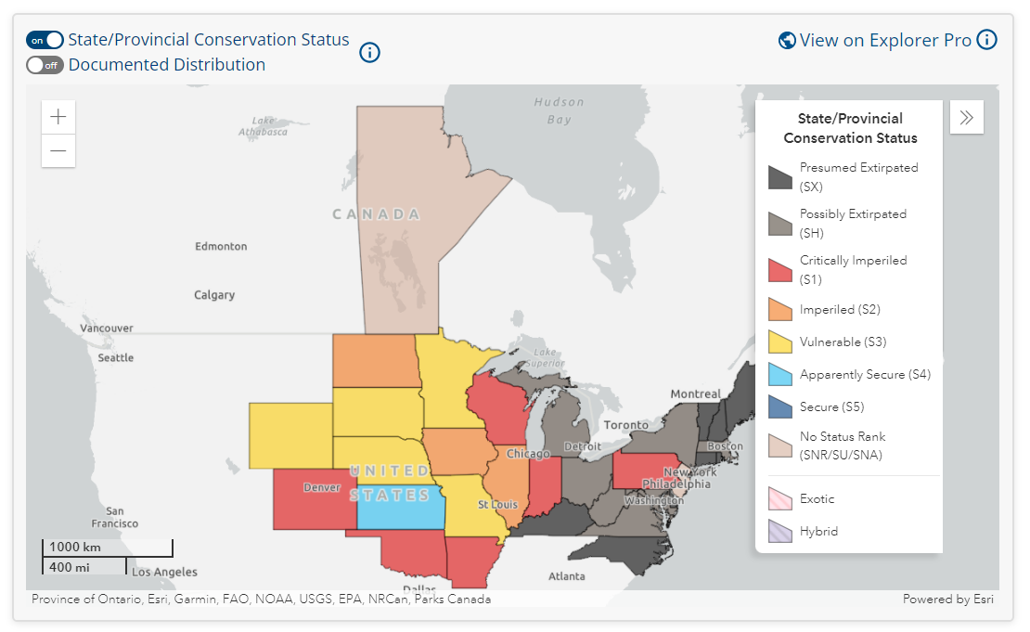
Figure 1. State and Provincial conservation status for the Regal fritillary (from NatureServe Explorer https://explorer.natureserve.org/Taxon/ELEMENT_GLOBAL.2.114908/Argynnis_idalia).

Summary of Adaptive Capacity

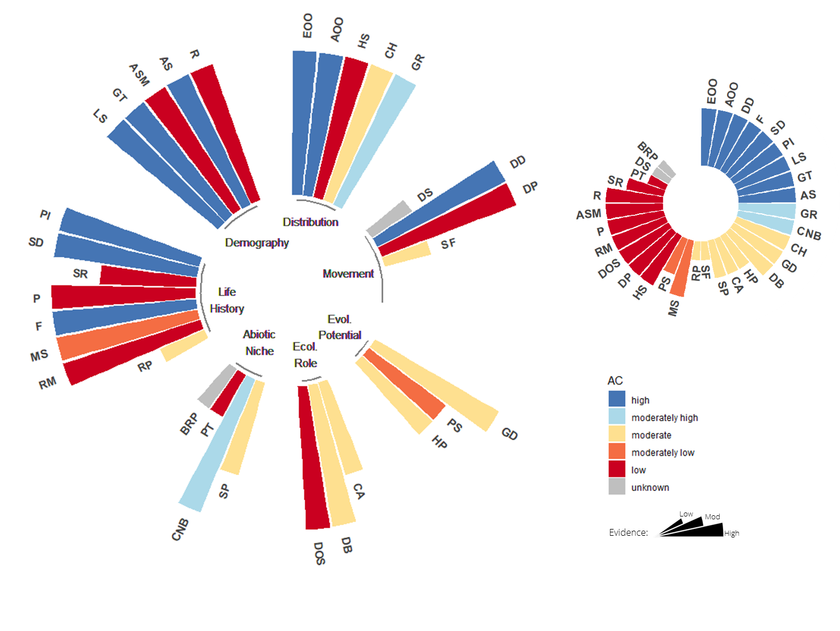
Figure 2. The adaptive capacity of the Regal fritillary (Arinnis idiala occidentalis) is represented by 32 attributes grouped into seven attribute complexes, color-coded by level of adaptive capacity. Migratory attributes were considered not applicable to this species. Length of each spoke in the wheel indicates the strength of evidence (shorter spokes reflect less evidence available to support the assessment of a given attribute). Chart inset (top right) provides a summary of adaptive capacity, arranged by level of AC and strength of evidence.
EOO = Extent of Occurrence; AOO = Area of Occupancy; HS = Habitat Specialization; CH = Commensalism with Humans; GR = Geographic Rarity; DS = Dispersal Syndrome; DD = Dispersal Distance; DP = Dispersal Phase; SF = Site Fidelity; MF = Migration Frequency; MDe = Migration Demography; MT = Migration Timing; MDi = Migration Distance; GD = Genetic Diversity; PS = Population Size; HP = Hybridization Potential; CA = Competitive Ability; DB = Diet Breadth; DOS = Diversity of Obligate Species; SP = Seasonal Phenology; CNB = Climatic Niche Breadth; PT = Physiological Tolerances; BRP = Behavioral Regulation of Physiology; RP = Reproductive Phenology; RM = Reproductive Mode; MS = Mating System; F = Fecundity; P = Parity; SR = Sex Ratio; SD = Sex Determination; PI = Parental Investment; LS = Life Span; GT = Generation Time; ASM = Age of Sexual Maturity; AS = Age Structure; R = Recruitment.

Distribution
About 95-99% of original habitat has been lost and some remaining scraps lack this species. Decline has greatly slowed but several studies document recent losses, in some cases to excessive prescribed burns. This subspecies appears quite restricted to prairie remnants including prairie pastures that may be slightly disturbed or somewhat degraded. These prairies range from xeric to wet, and ideal habitat may be places with abundant violets in both dry and wet microhabitats. The greatest threat the regal fritillary faces is habitat loss, fragmentation, and degradation. Row crop agriculture, urban developments such as housing and business construction, road construction, and gravel mining all contribute to the disappearance and degradation of prairies.

Movement
Regal fritillaries are a patrolling species. Adults are not migratory but are known to have greater dispersal capacity that other prairie specialist butterflies. Where Regal fritillaries occur in complexes of closely associated prairie fragments, dispersal between fragments can occur. They are capable of strong and rapid flight, and sometimes wander extensively late in the season, but population recovery will take longer if it depends on recolonization between fragments, and the probability of successfully repopulating distant, isolated habitat fragments is low. Therefore, where regal fritillaries occur in an isolated prairie fragment, it should be assumed that recolonization will need to occur from within that fragment.

Evolutionary Potential
Prairie populations of Regal fritillaries are described as a subspecies separate from the typical now nearly extinct eastern version of this species based on morphometrics and mitochondrial DNA. With a loss of more than 99% of the original native tallgrass prairie, decreased sustainable habitat area for the Regal fritillary has become a real threat. Drastic declines in Regal fritillary populations have led to much concern about the butterfly's persistence. All but three remaining populations (as of 2007) are this subspecies. The ability of this subspecies to colonize new sites and the extent of gene flow are not well documented. However, smaller fragmented populations are susceptible to restricted gene flow, reduced genetic variability, and population bottlenecks. As habitat fragmentation continues to increase, genetic problems may become a real threat, disrupting gene flow, increasing disease susceptibility, and limiting evolutionary adaptive capacity.

Ecological Role
While many populations feed as larvae mostly on prairie violet (Viola pedatifida), several other violets are also commonly used where available. Adults require nectar, probably continuously, from about June to September and utilize a variety of native and non-native flowers, including thistles, various late summer composites, and milkweeds. Availability of adult nectar plants throughout the summer flight time can be as important as the presence of larval food plants in determining whether an area can support populations.

Abiotic Niche
Although the climatic niche breadth for this species is broad, the Regal fritillary is highly sensitive to environmental and climatic factors year-round. First instar larvae are highly sensitive to extreme weather conditions as they overwinter in the leaf litter and as they begin their search for food plants in the spring. Hard frosts late in the spring, severe storms, and cool damp conditions have all been shown to negatively impact larvae survival. Unusually cool conditions in the spring can drastically slow larval growth rates, increasing their exposure to mortality factors. Environmental factors can limit adult regal fritillary activity as well. Prolonged periods of cooler temperatures, cloudy skies, and rain can restrict normal activities, perhaps limiting reproduction. Potential phenological asynchrony between the fritillaries and their nectar plants and larval foodplants due to climate change warrants further investigation.

Life History & Demography
The life cycle of the Regal fritillary is thought to be an adaptation to the phenology of their larval food plant, the violet. These small perennial violets produce abundant foliage in the spring for the growing larvae. However, in most areas they senesce in the heat of the summer and become unavailable to the larvae at that time. When this occurs, the Regal fritillary is entering into its adult life and is no longer dependent on the violet. The fact that the violets remain unable to support larvae throughout the rest of the summer helps to explain the regal fritillary's univoltine life cycle. Their life cycle, single generation per year, egg-laying behavior, slow caterpillar growth, and need for correct food plants at a critical time, makes them vulnerable to habitat disturbance and climate change.

