Adaptive Capacity

Grasshopper Sparrow (Ammodramus savannarum)

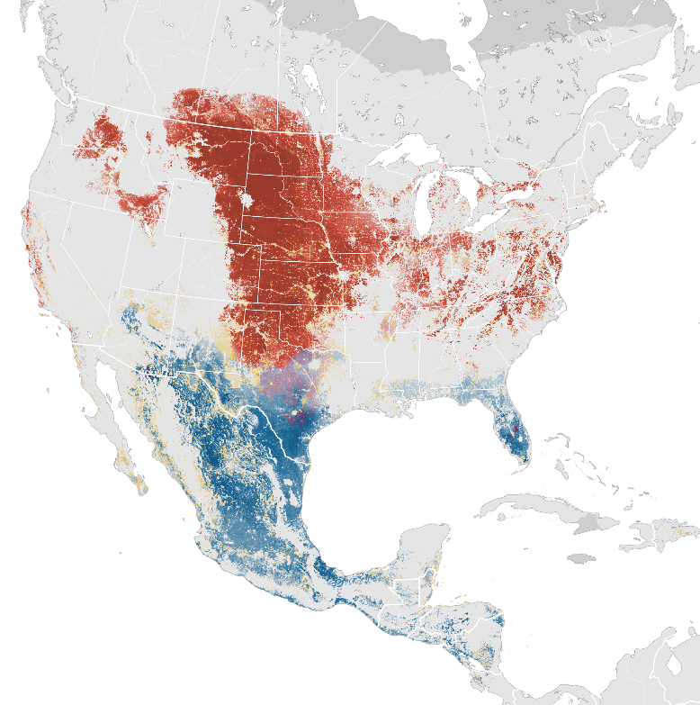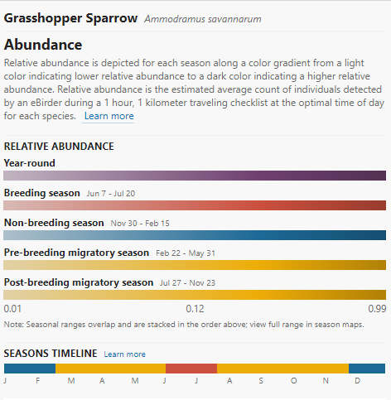
Figure 1. eBird data from 2007-2021. Estimated for 2021. Fink, D., et al. 2022. eBird Status and Trends, Data Version: 2021; Released: 2022. Cornell Lab of Ornithology, Ithaca, New York. https://doi.org/10.2173/ebirdst.2021

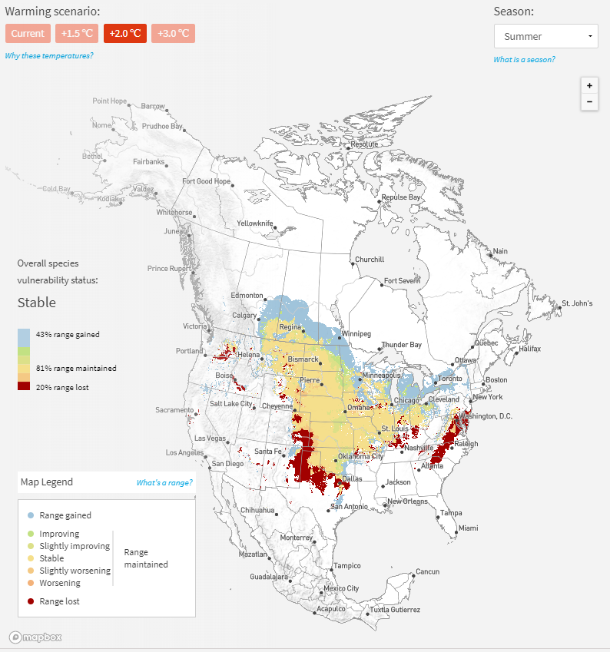
Figure 2. Future projection, under 2.0 °C warming, of climate suitability for the Grasshopper sparrow during the summer season (from Audubon Guide to North American Birds; https://www.audubon.org/field-guide/bird/grasshopper-sparrow).

Summary of Adaptive Capacity

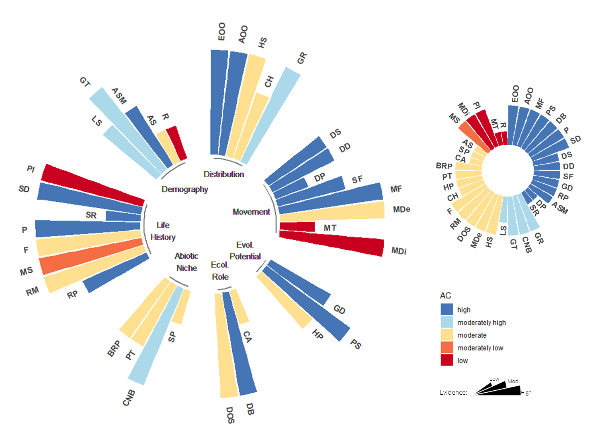
The adaptive capacity of the Grasshopper sparrow (Ammodramus savannarum) is represented by 36 attributes grouped into seven attribute complexes, color-coded by level of adaptive capacity. Length of each spoke in the wheel indicates the strength of evidence (shorter spokes reflect less evidence available to support the assessment of a given attribute). Chart inset (top right) provides a summary of adaptive capacity, arranged by level of AC and strength of evidence.
EOO = Extent of Occurrence; AOO = Area of Occupancy; HS = Habitat Specialization; CH = Commensalism with Humans; GR = Geographic Rarity; DS = Dispersal Syndrome; DD = Dispersal Distance; DP = Dispersal Phase; SF = Site Fidelity; MF = Migration Frequency; MDe = Migration Demography; MT = Migration Timing; MDi = Migration Distance; GD = Genetic Diversity; PS = Population Size; HP = Hybridization Potential; CA = Competitive Ability; DB = Diet Breadth; DOS = Diversity of Obligate Species; SP = Seasonal Phenology; CNB = Climatic Niche Breadth; PT = Physiological Tolerances; BRP = Behavioral Regulation of Physiology; RP = Reproductive Phenology; RM = Reproductive Mode; MS = Mating System; F = Fecundity; P = Parity; SR = Sex Ratio; SD = Sex Determination; PI = Parental Investment; LS = Life Span; GT = Generation Time; ASM = Age of Sexual Maturity; AS = Age Structure; R = Recruitment.

Distribution
Although the Grasshopper Sparrow appears to have a wide distribution across much of North America, it is often locally distributed and even uncommon to rare throughout parts of its range. Many populations have experienced long-term declines since the early part of this century, owing mostly to loss and conversion of prairies to agricultural grasslands. In the breeding season, this sparrow generally occupies intermediate grassland habitat, preferring drier, sparser sites in lush tallgrass prairies and eastern grasslands, and thicker, brushier sites in shortgrass prairie and southwestern grasslands. Species generally prefers moderately open grasslands and prairies with patchy bare ground but selects different components of vegetation, depending on grassland ecosystem. Due to its widespread distribution and flexibility in site selection, climate change vulnerability will likely be eco-regionally specific based on climatic, habitat, or other environmental factors that may affect habitat quality, particularly in wintering grounds.

Movement
Grasshopper sparrows are a highly vagile species capable of long-distance migration and relatively high dispersal distance. However, little is known about natal dispersal and, more broadly, about the potential environmental or climatic cues for dispersal and migration. This information is needed to provide a thorough assessment of their movement capacity and consequent ability to track suitable climate across the landscape. Evidence in support of low site fidelity indicates a potential for effective climate tracking. For migratory species like the Grasshopper sparrow, adaptive capacity can be affected two-fold by climate change through impacts to both over-wintering and breeding grounds. In these instances, practitioners may focus efforts on the region or habitat that will be most limiting to the species adaptive capacity or most impacted by climate change. Similar to other aspects of the species life history, more information is needed as to their reliance on climatic cues for migration.

Evolutionary Potential
Global population size of the Grasshopper sparrow is large, with regionally specific population numbers and trends. A slight global population decline of ~3.9% has been observed over the last 50 years. Implications for genetic diversity are unknown as studies of population genetics are restricted to the Florida subspecies. However, the endangered Florida subspecies has relatively high genetic diversity for its population size, likely owing to the species vagility. More genetic studies in populations outside of Florida are needed to inform evolutionary potential and gene flow.

Ecological Role
Grasshopper sparrows are notably reliant on grasshoppers as preferred diet, but are largely considered to be diet generalists. No information is available as to competitive interactions with other grassland bird species, however, nest parasitism by brown-headed cowbirds is a significant problem that may be exacerbated under climate change if range expansions of cowbirds occurs. Potential changes in the co-occurrence of these species warrants further investigation, especially as it has implications for breeding success.

Abiotic Niche
The climatic niche for the global population is obviously quite broad. Information from Mexico suggests wintering grounds may be most vulnerable to climate change, specifically changes in precipitation and increasing drought conditions. Heat stress is also known to affect juvenile survivorship. Habitat availability will likely be a primary limiting factor for the species ability to shift in space. More information is needed on important regional and seasonal climate change factors and the species physiological tolerances, including any behavioral flexibility that may offer buffering capacity.

Life History & Demography
Timing and length of breeding season varies according to subspecies, disturbance factors (e.g., fire), weather, and site. Grasshopper sparrows can generally produce at least 2 broods annually, even in northern portion of range. This is critical for a ground-nesting species that generally experiences moderate to high levels of nest predation. Given the species relatively low fecundity, vulnerability to brood parasitism, altricial nestlings, and cooperative breeding strategy, this period of the species life cycle (breeding season and associated habitat) will likely be a primary limiting factor for the species adaptive capacity and vulnerability to climate change. Very little demographic information is available for this species, including age structure, population sex ratios, and recruitment. This information would help to inform assessments of population viability, especially given ongoing declines.

